UNIT/03: EDUCATION AND EMPLOYMENT
READING
IN THIS unIT YOU WILL
LEARN HOW TO
- identify the main ideas of a passage
- find information in a text quickly
- deal with multiple-choice questions.

Lead-in

 | Are these words about work or studies? Put them in the correct column. | TIP 01
  01
  academic | blended learning | business
  degree | employers | retirement
  job | qualification | primary education
  office | lifelong learning | seminars
  Work | Studies
  Divide your vocabulary notebook into topics. Leave space to add new words as you learn them.
 | How many of the words can you find in the text opposite in ONE minute?
  02

[[[[[[[[[[MULTIPLE-CHOICE QUESTIONS]
  FINDING THE ANSWER
   | Spend another ONE minute quickly reading the text and answer this question.  Does the text express a positive or negative view of globalisation in education?
    03
   | Spend another ONE minute quickly reading the text and answer this question.
    04
    - Blended learning means  - continuing to learn throughout your life.  - studying online or via email.  - mixing traditional and modern methods.  - learning in a classroom. | - All of these are advantages of globalised education except  - Students in developing countries can get better jobs.  - Students can get a degree at a cheaper price.  - Universities benefit from international students.  - The elite get most of the opportunities.
  ◉ In multiple-choice questions, you have to choose the correct answer from four options: A, B, C, D.
  In the test, you will not have time to read the whole passage in detail. You need to quickly find the part of the text that contains the answer.
  First, skim the text (read it very quickly) so you know what it is about.
  Next, look at the main part of the questions (NOT the options A, B, C, D) and decide which words will help you find the answer. These are the 'key' words.
  Then, read the text again quickly. This time you are only looking for the key words or words which mean the same. That is the part of the text where the answer is.

GLOBALISATION OF EDUCATION AND THE WORKPLACE
A  Globalisation has affected most aspects of our lives. One area which has changed is education. More and more people move to different countries for their studies. At the same time, more people stay at home and study by distance learning. It is now easy to learn without attending a college or university, or attending less often. 'Blended learning' means studying partly in a traditional way in the classroom and partly online or via email. These changes also mean that there is now more interest in 'lifelong learning', the idea that we go on learning throughout our working lives and even into retirement. It is easy to attend 'webinars' or online seminars without being away from our offices. Many adults go back to college later in life because it is so easy to get a qualification without giving up work or disrupting family life.  B  Different countries have benefitted from the globalisation of education in different ways. Many British, Australian and American universities run their degree programmes in countries throughout Asia, and many students, parents and employers feel this is a valuable opportunity. Students can get an internationally recognised degree at a much cheaper price than going abroad and so can improve their chances of getting a good job. At the same time, those in the countries providing world-class degrees also benefit. They have greater access to ideas and knowledge from all over the world and having international students enriches their universities.  C  However, it is not good news for everyone in some developing countries. It is usually the elite - or the richest people in the large cities - who have access to international education. Many people in rural areas have not even had a primary education. Also, those areas usually do not have reliable internet connections and most people do not own a computer. It will take a bit more time for international opportunities to reach everyone in developing countries. | D  One concern people have about globalisation is that it can start to mean 'westernisation'. In other words, local knowledge can be lost and money seen as more important than culture. Education should treat every culture with respect; it should not be just learning about the West, but should include different ways of teaching and approaches from around the world. The aim is to enrich and share; the flow of ideas and information should go from East to West as well as from West to East.  E  Educational institutions have changed their focus due to globalisation. There are so many benefits of having overseas students that universities are competing for them, using strategies from the world of business. For example, they visit Education Fairs all over the world and spend time and money creating publicity material and advertisements. There is also more emphasis on the student experience. There is more focus on customer care, especially helping international students to settle in, improve their English and understand the academic culture of the host country.  F  There are many advantages to the globalisation of education and the workplace. More people get benefits that were only available to those in the developed countries before. There is more understanding between different nations as people learn about each other's cultures. However, it is important to make sure the benefits reach everyone and don't leave many citizens of the developing world behind.

LOOKING FOR WORDS WITH SIMILAR MEANINGS

 | If you see these words (1-7) in a question, what words might you expect to find in the text? Choose a word or phrase from the box below.  The words you don't need are examples of the type of words which are likely to be the same in both the question and the text.
  05
  - abroad  - benefits  - disturbing  - going to | - make better  - useful  - workplaces
  advantages | attending | distance learning | overseas
  globalisation | enrich | lifelong learning | offices
  Disrupting | valuable | westernisation
  ◉
  - Sometimes the words in the text are the same as the key words in the question, for example the technical term 'blended learning'.
  - Sometimes the words in the text are different to the key words, but they mean something similar.
  - When you are looking for the key words in the text, it is important to look for words, or groups of words, that mean the same. We call these 'paraphrases'.

IDENTIFYING THE MAIN IDEA

 | Which FOUR sentences represent the main ideas of the passage?  - There are both advantages and disadvantages to the globalisation of education.  - Many people study after retirement.  - It is important that globalisation should not be westernisation.  - Universities have had to become more business-focused.  - University fees rose dramatically in the UK in 2012.  - Many poorer people in developing countries do not benefit from globalisation.  - Most lecturers work part-time.  Where in the paragraph can the main ideas be found? | TIP 06
  06
  ◉ Questions often relate to the main ideas of the passage. It is therefore important that you are able to identify them.
  Read the first paragraph and the first sentence of every other paragraph, as this is where the main ideas can usually be found.

MULTIPLE-CHOICE QUESTIONS: ANOTHER WAY TO DO THEM

 | Write your own answers to these questions.  - Who benefits from globalised education in developing countries?  - What is the meaning of 'westernisation'?  - How has the focus of educational institutions changed?  Look at the options and find the one closest to your answer.  - Who benefits from globalised education in developing countries?  - almost everyone in those countries  - mainly well-off people in big towns  - only those in developed countries  - only those who own a computer  - What is the meaning of 'westernisation'?  - learning only about the West  - learning local knowledge  - not learning about culture  - treating culture with respect  - How has the focus of educational institutions changed?  - They have become poor value for money.  - Staff are not committed to their students.  - They are focused on attracting students.  - They only want foreign students.  Then read the passage again and answer the questions. Was it helpful to try to answer the question yourself first? | TIP 06
  07
  ◉ Questions often relate to the main ideas of the passage. It is therefore important that you are able to identify them.
  Read the first paragraph and the first sentence of every other paragraph, as this is where the main ideas can usually be found.

GRAMMAR FOCUS: THE PRESENT PERFECT

 | Look at this example of the present perfect from the first sentence of the passage:  Globalisation has affected most aspects of our lives.  Did this happen in the past or present? -It began in the past.  Does it have results in the present? -Yes. We are still affected by globalisation.  Look at the options and find the one closest to your answer.  - Look at these present perfect sentences from the passage. Do they relate to both the past and the present? How?  - Different countries have benefitted from the globalisation of education in different ways.  - Many people in rural areas have not even had a primary education.  - Educational institutions have changed their focus due to globalisation.  - Which of these tenses is used most in the passage?  - simple past  - simple present  - present continuous  - Choose the best reason for this choice of tense.  - The situation affects people now.  - Most of the changes happened in the past.  - It is a constantly changing situation. | TIP 06
  08
  ◉ Questions often relate to the main ideas of the passage. It is therefore important that you are able to identify them.
  Read the first paragraph and the first sentence of every other paragraph, as this is where the main ideas can usually be found.

[[[[[[[[[[EXAM SKILLS]
 | Read the text on work-based learning and answer the questions that follow.
  09
  ◉
  - Read (skim) the text very quickly so you understand what it is about.
  - Read the main part of the questions and find the key words (the words
  - that will help you find the answer in the passage).
  - Find the key words or words that mean the same in the passage.
  - Try to answer the question without looking at the options A-D.
  - Find the option, A, B, C or D, that matches your answer.
  - Check that the other options are incorrect.

EDUCATION
AND THE WORKPLACE
IN THE UK

A  There has been a trend towards creating a closer connection between education/training and the workplace. This is because many employers felt that school leavers were not prepared well enough and didn't have the skills they would need to do well at work. Having a close relationship between training and work is not new: apprenticeships were a common way of learning in the past. Young people learnt by working with an expert, but this was most common in trades such as builders or electricians. The trend now is for a closer connection between education and the workplace at all levels and in many different types of job.  B  In 1944, the UK government created a new system of education. Education was divided into three parts. Children who passed an exam at 11 went to grammar schools. Pupils who didn't do well in the exam went to 'secondary modern' schools or technical schools. At technical schools they studied work-based subjects. In practice, however, only 0.5% of pupils went to technical schools, and this system divided students at a very young age into academic and non-academic. The system did not produce good results, and changed to a more equal system in the 1970s. B  C  In the 1980s the British government introduced NVQS or National Vocational Qualifications so that young people could get certificates to show their practical skills. It helps employers understand what workers can do. In 1994, the government started a programme which aimed to provide 'quality training on a work-based (educational) route'. These 'modern apprenticeships' are available at three different levels. | D  At the higher levels of education, too, there has been more emphasis on work-based learning, which links academic study closely to practical experience. At degree level, companies have linked with universities to create specialised qualifications, such as the BA in Distribution run between Middlesex University and Asda Supermarket. Such partnerships also exist at Masters and even doctorate level.  development of technology has helped work-based learning to develop. Blended learning means part of the course can be delivered online, so people don't have to miss work to go to classes. Older or recently retired employees have been given the opportunity to develop new skills as tutors, mentors and coaches for the work-based part of these courses. This kind of work-based training was common in fields such as nursing and teaching, but has now spread to careers which were traditionally not closely linked to education.  F  There are some challenges involved in work-based learning. Some lecturers might find it difficult to teach students with a lot of work experience. It may also be difficult to find teachers who can teach in different places and at different times. However, it is a positive trend as there are more ways to learn and people can study at different stages of their lives.

- Apprenticeships  - are a new way of learning.  - were common in the past.  - only existed in the past.  - did not help people do well at work.  - The education system introduced in 1944  - only affected 0.5% of students.  - taught only technical subjects.  - was not a great success.  - was for academically gifted students. | - Blended learning  - mainly benefits older or retired people.  - involves mainly face to face classes.  - is mainly for teaching and nursing.  - is convenient for working people.  - The challenges of work-based learning include  - practical issues like when classes are held.  - students who are not very experienced.  - more types of learning are acceptable.  - older people can't use computers well.

UNIT/03: EDUCATION AND EMPLOYMENT
WRITING
IN THIS unIT YOU WILL
LEARN HOW TO
- describe different types of data
- describe changes in numbers
- use prepositions with numbers.

Lead-in

 | Match the diagrams with their names. Which of them describe changes to numbers over time?
  01
  table | bar chart | pie chart | line graph
  % of graduates in the population (UK)  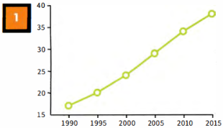 | Which English-speaking country do foreign students want to study in?  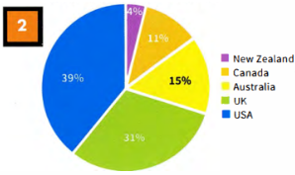
  Participation of 18-year-olds in education and training, 2014  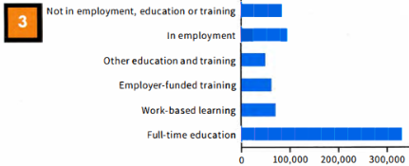  Not in employment, education or training  In employment  Other education and training  Employer-funded training  Work-based learning  Full-time education |  | New entrants to primary teacher training programmes 2007 - present  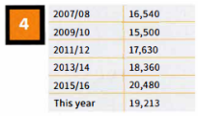

DESCRIBING CHANGES IN NUMBERS

 | Put the words into the correct column. Are they verbs (V), nouns (N) or both?
  02
  decline | decrease | drop | fall | growth | increase | rise
  ↑ | ↓
 | Write the past simple and past participle forms of the verbs.
  03
  infinitive | past simple | past participle
 | Use the correct verb or noun form of one of the words from above to complete the sentences about the table.  New entrants to primary teacher training programmes 2007 - present  - The number of new entrants to primary teaching during _____ the period.  - There was a ____ from 2007/08 to 2009/10.  - There was a steady ___ in numbers from 2009/10 to 2015/16.  - The numbers ___ again this year.
  04
  2007/08 | 16,540
  2007/08 | 16,540
  2009/10 | 15,500
  2011/12 | 17,630
  2013/14 | 18,360
  2015/16 | 20,480
  This year | 19,213

[[[[[[[[[[GRAPHS AND BAR CHARTS]
 | Which is the better description of the line graph: A or B? Why? | TIP 05
  05
  - The graph shows the percentage of graduates in the UK population between 1990 and 2015. In 1990 17% of the population of the UK were graduates. This rose to 20% in 1995 and 24% in 2000. In 2005, it went up to 29%, in 2010 to 34% and up to 38% in 2015.  - The graph shows an upward trend in the % of graduates in the population between 1990 and 2015. The percentage rose gradually throughout the period. It increased by about 3 to 5% every five years, for example between 1990 and 1995 it increased from 17 to 20%. | % of graduates in the population (UK)  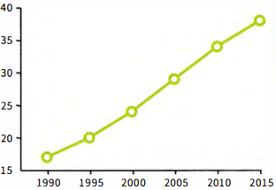
  Select information that is important-don't include everything. You must include some data to support your description.
 | Read sentences 1-9 about the bar chart, and answer the questions.
  05
  - Which TWO sentences should NOT be included? | - Which of the other sentences include the most important information about the bar chart, do you think?
  - There were about 330,000 18-year-olds in full-time education.  - Work-based learning is really useful for young people.  - 60,000 were in employer-funded training.  - Around 70,000 of the age group were involved in work-based learning.  - Only about 50,000 were in the 'other education and training' category.  - There were three times more 18-year-olds in full-time education than in employment.  - The situation is very different in my country.  - About 90,000 were not in employment, education or training.  - More 18-year-olds were in employment than not in employment, education or training. | Participation of 18-year-olds in education and training, 2014  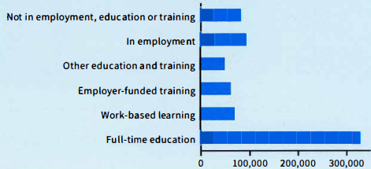  Not in employment, education or training  In employment  Other education and training  Employer-funded training  Work-based learning  Full-time education
 | Complete the sentences with a preposition from the box.  - 17% ___ the population are graduates.  - The number ___ graduates went up.  - It rose ___ 21% ___ 29%.  - It increased ___ about 4%.  - ___ 1992 and 1996 there was an increase.  - There was a rise ___ graduate numbers during the 1990s.
  07
  between | in | from | of | of | to | by

STUDYING A MODEL ANSWER

 | Read the model answer and find:  - the introductory sentence  The diagram demonstrates the process of preparing stringhoppers, a kind of noodle dish.  - the overview  There are six main stages in the process, beginning with grinding the rice and making a dough and ending with using a steamer to cook the stringhoppers.  - a description of data  First, Next, After that, then, The final stage is  - some data to support the descriptions  is put, is mixed, (is) formed, is put, is pushed, are placed, are... cooked  - past simple verb forms  a metal piece of equipment with two handles and holes in it; round baskets made of thin pieces of wood  - a present perfect verb form  grind, rice, dough, steamer, grinder, flour, stringhopper press, stringhopper mats, cook, serve, spicy, curries  in exercise 4  Why is the past simple used more than the present perfect? | MODEL ANSWER
  08
  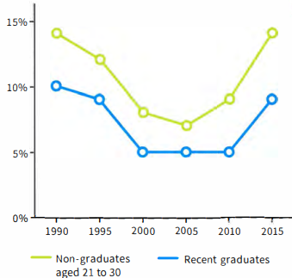
  The line graph shows the number of unemployed recent graduates and non-graduates in the population of 21 to 30-year-olds in the years between 1990 and 2015. Overall, the numbers have not changed much; we can see a fall, followed by a rise, in both groups. The non-graduates are a larger number than the recent graduates at all points.
  Between 1990 and 2000 there was a decrease in the number of unemployed recent graduates and non-graduates. The fall was small from 1990 to 1995, but greater between 1995 and 2000. There was a small change in the middle period. The number of non-graduates dropped and then grew during that period. Over the five years from 2010 to 2015, the numbers of both non-graduates and recent graduates returned almost to their 1990 figures of 14% and 10%.
  Overall, it is clear that having a degree is helpful in finding employment as more non-graduates than recent graduates are out of work.

[[[[[[[[[[DESCRIBING A PIE CHART] | TIP 09
   | Which country matches these phrases?
    09
    - over a third  - a little under a third  - the lowest number of students  - about 1 in 10  - just under a sixth  - the most popular country  - the country in second place  - the least popular country
      Which English-speaking country do foreign students want to study in?
      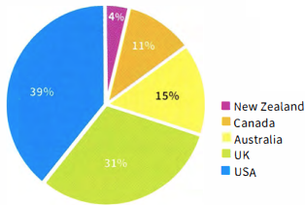
  ◉ In multiple-choice questions, you have to choose the correct answer from four options: A, B, C, D.
  In the test, you will not have time to read the whole passage in detail. You need to quickly find the part of the text that contains the answer.
  Select information that is important-don't include everything. You must include some data to support your description.

[[[[[[[[[EXAM SKILLS]
 | Look at the Writing Part 1 task below. Before you start writing, answer these questions about the graph.  - What are the two groups in green and purple?  - What do the vertical and horizontal axes show?  - Which two regions had the highest literacy rates?  - How many regions show different literacy rates for men and women?  - Which region shows the biggest difference between men and women?  - What are the male and female literacy rates in the least literate region?  - What is the percentage difference between the most and least literate areas?  You should spend about 20 minutes on this task.  The bar chart shows the literacy rate (% of people who can read and write) by region and gender in 2011.  Summarise the information by selecting and reporting the main features, and make comparisons where relevant.  Write at least 150 words.
  10
  Literacy rate by region and gender 2011
  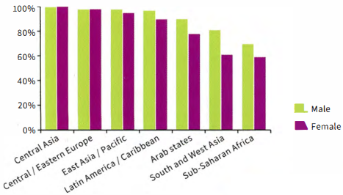
  Central Asia
  Central/Eastern Europe
  East Asia/Pacific
  Latin America/Caribbean
  Arab states
  South and West Asia
  Sub-Saharan Africa
 | Write your answer.  Remember to:  - include introductory and concluding sentences and an overview  - use expressions with prepositions  - use the past simple tense.
  11

UNIT/03: EDUCATION AND EMPLOYMENT
LISTENING
IN THIS unIT YOU WILL
LEARN HOW TO
- identify key words in sentence completion tasks
- use strategies to help you answer sentence completion tasks
- follow a conversation
- recognise synonyms and paraphrase.

Lead-in
 | Pictures A-G show different areas of work or study. Match the pictures with the words in the box.
  01
  hotel and catering | construction | health | sports and leisure
  information technology | art and design | retail
   |  | 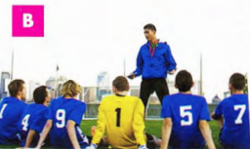 |  | 
   | 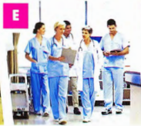 |  |  |  | 
  ◉ In the Listening test you may hear people talking about their area of work or studies. And in the Speaking test you may have to talk about your job or your course. It is important to understand and use words related to these topics to help you do this.
 |  | Look at the words in the box. Do they describe a job or a type of course?  Put J for 'job' or C for 'course' next to each word. The first one has been done for you.
  02
  architect J | chef | building engineering | badminton coach
  computing | doctor | fitness training | food technology
  graphic designer | medicine | shop management | store assistant

 | Complete the table. Use the words in exercise 2. There are two examples to help you.
  03
  Job | Area of work or study | Course
  - graphic designer | art and design
   | construction | building engineering
   | health
   | hotel and catering
   | information technology
   | retail
   | sports and leisure
 | Identify the TWO correct endings for each sentence.  - I've done a course in computing/ badminton coach / food technology.  - My sister has worked on a cruise ship as a chef/medicine/doctor.  - Our son had a job as a(n) architect / store assistant/building engineering.  - He's very keen on web designer/fitness training/textiles. | TIP 10
  04
  It is important to listen carefully to the ending of words. For example, words ending in -ology and-tion can be used to talk about different areas of work or study. Words that end in -er may refer to people and jobs.
 | Listen to two short conversations. Are the speakers talking about a job or a course? Put J for 'job' or C for 'course'.
  05
[[[[[[[[[[SHORT-ANSWERQUESTIONS]

 | Read the questions and underline the key words.  The first one has been done for you.  - What did the speakers order in the restaurant?  - How much did each person pay for their meal?  - What time is the bus due?  - Where is the bus stop?  - How long did the course last?  - Which TWO things did the speaker do on the course?  - What is the date of the next course?  - Who will lead the course?
  06
  ◉ You often use short answers in note completion tasks. In this type of task you answer questions using up to three words, or two words and/or a number.
 | Complete the table. Use the key words in the questions in exercise 6 to help you. The first one has been done for you.
  07
  Which questions need ••• | Question
  - a date  - a price  - a period of time  - a time  - a meal or a kind of food  - a name of a person  - the names of activities or skills  - a place? | 7

 | Look at the table you completed in exercise 7. For which questions do you need to write a number?
  08
 | Listen to the conversation and answer the questions.  Write NO MORE THAN ONE WORD AND/OR A NUMBER for each answer.  18  - What did both speakers order?  - How much did each person pay for the meal? £
  09
 | Read this question about a shopping trip, and choose the correct answer.  Why is the other answer incorrect?  Answer the question. Write NO MORE THAN ONE WORD AND/OR A NUMBER for each answer.  What did the boy buy in the shopping mall?  Answer: shoes / he bought shoes | TIP 10
  10
  It is important to check the instructions carefully to see how many words you can write in your answer.
 | Listen to the conversation and choose the correct answers.  Why are the other answers incorrect?  Answer the questions. Write NO MORE THAN ONE WORD AND/OR A NUMBER for each answer.  19  - What time is the bus due?  seven fifteen / seven fiftty/7.15/7.50 pm  - Where is the bus stop?  Blithe Road / Blith Road / Blythe Road / Blyth Road | TIP 11
  11
  It is important to check your spelling carefully. If you spell the word incorrectly, your answer will be marked wrong. When you need to answer a question with a number, it is easier and quicker to write it as a number rather than writing it in words. And also you are less likely to make a mistake.

 | Listen to Alicia telling a friend about a sailing course and answer the questions.  Write NO MORE THAN ONE WORD AND/OR A NUMBER for each answer.  20  - How long did the sailing course last?  - What was the first thing that Alicia learnt?  - What is the date of the next course?  - Who will lead the next course?
  12

[[[[[[[[[[EXAM SKILLS]

 | Read questions 1-8 below. For which questions do you need to write a number ONLY?
  13
 | Find the key words in questions 1-8 below.
  14
 | Listen and answer questions 1-8.  Then read your answers carefully.  21  - Did you check your spelling?  - Did you write numbers in digit form?  - Did you check that you have written the correct number of words?  Questions 1-5  Answer the questions below. Write NO MORE THAN TWO WORDS AND/OR A NUMBER for each answer.  - 1 What kind of tour did the woman do?  - How did she find out about the tour?  - How many people were on the tour?  - What is the address of the hire shop?  - How much did each student in the group pay? $  Questions 6-7  Which TWO items were included in the cost of the hire?  6  7  Question 8  What is the website address of the hire shop?
  15

UNIT/03: EDUCATION AND EMPLOYMENT
SPEAKING
IN THIS unIT YOU WILL
LEARN HOW TO
- use prepositions to talk about your home town
- use adjectives to describe your home town
- use the correct tense when responding to questions
- pronounce regular and irregular past simple tense endings.

Lead-in

 | What tense would you use to answer these questions? Select the correct answer A-C below.  - Is there much for young people to do in your home town?  - What was your home town like in the past?  - Has your home town changed since you were a child?  - Present perfect, e.g. Many things have changed in my home town over the years.  - Present simple, e.g. There are lots of things for young people to do in my home town.  - Past simple, e.g. There were more factories and the houses were smaller.
  01
 | Now, with a partner, ask and answer the three questions in exercise 1.
  02

[[[[[[[[[[ANSWERING PART 1 QUESTIONS]

USING PREPOSITIONS TO DESCRIBE YOUR HOME TOWN

 | Listen to a boy describing his home town and read the script.  Match the places the boy talks about with A - H on the map.  22
  03
  town hall H | library | art gallery | cinema
  shopping mall | harbour | stadium | swimming pool
  Well, I live in a small town in the north of my country. It has quite a few interesting places to visit. For example, in the centre of town, on the north side of the square we have the historic town hall, which was built in 1895. In front of it, there's a beautiful fountain. Opposite the town hall there's the library. Then if you go over the bridge, we have the art gallery, a big modern building, which often has interesting exhibitions. The art gallery is actually between the cinema (to the north) and a big shopping mall, where I often meet up with my friends.  To the south of the town, there's a harbour, where you can take a boat to the islands. And then next to the harbour is the stadium, where people go to watch our local football team. And just behind it is the public swimming pool. It's an outdoor pool-lovely in summer, but very chilly the rest of the year. | 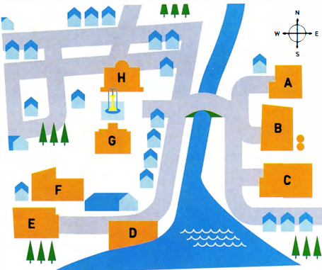
 | Now describe your home town. You might want to draw a map to help you.
  04

USING ADJECTIVES TO DESCRIBE YOUR HOME TOWN

 | Choose the correct heading from the box for the words and phrases in the table below.
  05
  Areas | Buildings | Climate | Location | Opinion
  1 Location | 2 ----- | 3 ----- | 4 ----- | 5 -----
  on the coast  in the north-east  in the centre  outdoor  inland | busy  crowded  dirty  exciting  lively  quiet | hot  humid  mild | industrial  business  financial | tall  historic  ordinary  modern  old

 | Look at the words and phrases in the box and write them in the correct column of the table in exercise 5.  With a partner, add two more adjectives of your own to the table.
  06
  ancient | colourful | cool | enormous | high-rise
  tourist | in the south | indoor | incredible | magnificent
  narrow | polluted | huge
 | Complete the sentences with pairs of adjectives from the table in exercise 5.  - I come from a very modern city. You can see --- and --- buildings everywhere.  - In summer it's very wet and uncomfortable in my town. It's very --- and ---.  - There's usually a light breeze from the sea, so it's very --- and ---.  - There's a lot of rubbish on the streets. It's quite --- and ---.  - There's a great atmosphere in my city, especially at night. It's very ---- and ---. | TIP 07
  07
  It is a good idea to use pairs of words with similar meaning when you talk about your home town.
  This shows the examiner that you have a good range of vocabulary.
  For example: A lot of people live and work in my city. It's very busy and crowded.
 | Look at the photographs below. Try to describe each place using the headings and the words in exercise 5.
  08
   | 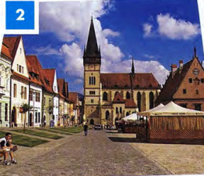 | 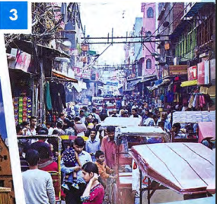

GRAMMAR FOCUS: TENSES

 | Read the questions on the examiner's card.  Then match them with the verb tenses.  Let's talk about the town or city where you grew up.  - Where did you grow up?  - Is it a good place to live?  - Do you think it has changed a lot? How? | TIP 09
  09
  present simple | present perfect | past simple
  ◉ In Part 1 of the Speaking test the examiner will ask you questions about familiar everyday topics such as your home town. To answer the questions you might need to use a range of tenses.
  It is important to listen very carefully to the questions the examiner asks you. This will help you to decide how to form your answer and what tense to use. One thing you can do is repeat or 'echo' the examiner's question to help you do this, but don't do this too often!

 | Read the Part 1 questions from different Speaking tests and choose the correct tense in the candidates' responses.  Listen and check your answers.  23
  11
  Examiner | Where were you born?
  Candidate 1 | I (1) am / was born in Dubai, in the Middle East. It (2) is / was as situated on the north-east coast of the United Arab Emirates.
  Examiner | Where did you grow up?
  Candidate 2 | I (3) am / was born in a small village in China, but I (4) grow up / grew up in Chengdu, which (5) is / was a very big city in south-west China.
  Examiner | Has your home town changed much since you were a child?
  Candidate 3 | In the last ten years Baku (6) changed / has changed a lot. Ten years ago we (7) haven't had / didn't have so many tall buildings and there (8) isn't / wasn't as much to do then. The biggest problem is that everything (9) is / was more expensive now.
  Examiner | Is there anything that you used to do in your home town that you don't do now?
  Candidate 4 | Well, I (10) used to / was used to go to the beach every summer when I (11) have been / was younger, but now I don't have time. One summer, I even (12) used to go/ went fishing. I'd like to do that again. Perhaps I'll have time next summer after my exams.
 | Listen to the sentences and tick the correct column, /t/, /d/ or /ɪd/ according to how the verb ending is pronounced.  24
  12
     | /t/ | /d/ | /ɪd/
    - bought
    - built
    - situated
    - called
    - located
    - changed
     | /t/ | /d/ | /ɪd/
    - developed
    - designed
    - discovered
    - started
    - used to
    - said
  ◉ In the past simple, the ending of the verb can be pronounced in one of three ways: /t/, /d/ and /ɪd/.
  Examples:
  /t/ work-worked
  /d/ play-played
  /ɪd/ decide-decided

 | Complete the sentences with ideas of your own. Then say them to your partner, pronouncing the verb carefully.  - Our family bought --- in the middle of town.  - The --- was built in ---.  - Our town is situated ---.  - The --- is called 'the ---.  - --- is located across from the ---.  - --- have/has changed over the years in my home town.  - --- was/were developed by the harbour.  - --- was designed by ---.  - Recently, scientists discovered --- near our village.  - Recently, many young people have started to ---.  - A long time ago many people used to ---.  - A tourist who visited recently said our town is ---.
  13
 | Read an examiner's questions, then listen to four students answering them. Match the speakers 1-4 with the examiner's questions a-d.  25  - What is your favourite place in your town?  - What do people do for fun in your town?  - Is it easy to travel around your town?  - What is the oldest part of your town?  Speaker 1 --- Speaker 2 ---  Speaker 3 --- Speaker 4 ---  Now ask and answer questions a-d with a partner.
  14
[[[[[[[[[[EXAM SKILLS]

 | Ask and answer the questions below about your home town with a new partner.  Listen to your partner's answers and note any new ideas or vocabulary you hear. Then, ask and answer the questions again and try to improve your answers.  - Can you describe the town where you grew up?  - What places of interest are there in your home town? Where are they?  - Is it a good place for young people? Why?  - Where do young people in your town meet their friends?  - What is your town like at night?  - How has your town changed in the last 10 years?  - Have any new buildings been built?  - A long time ago, where did people from your town used to work?
  15

